

Emmet and Speedy Html

# Adding ID and CLASS attributes.



To add a class or ID to an HTML element using Emmet, you can use the following syntax:



You can also add multiple classes or IDs to an element by separating them with a dot (.) for classes or a hash (#) for IDs.

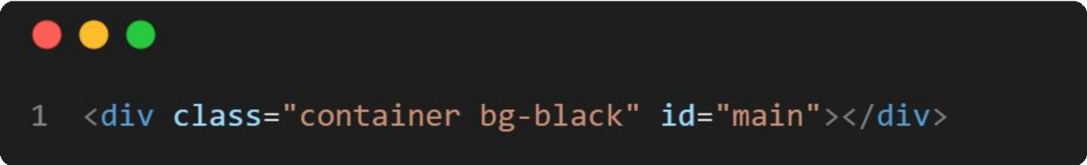

# Adding Custom Attributes



Using emmet, we may construct a tag with a certain attribute and pass its value. To accomplish this, we must enclose the element name in square brackets “[ ]”. We can include the name(s) of one or more attributes inside the bracket along with the value.



# Adding Text



Using emmet, we may also add sentences or paragraphs inside of tags. To do this, we must write the element name inside the curly brackets. The text item can be added within these curly brackets.



**THANK YOU**